Shell – Final Case Study Assessment

Shashikant Suman

Batch - 8

**Scenario:**

Streamline Solutions Inc. – Optimizing Software Deployment

**Problem Statement:**

Implementing a Seamless CI/CD Workflow for a Spring Boot Application using Azure Boards, Azure, Git, Maven, Docker, Github, Github Actions

**Background:**

Streamline Solutions Inc. is a dynamic technology company specializing in cutting-edge software solutions. The company is developing a sophisticated Java Spring Boot application designed to revolutionize user experience. To ensure a swift and error-free software deployment process, Streamline Solutions is seeking to establish an efficient Continuous Integration and Continuous Deployment (CI/CD) workflow.

**Activities:**

1. Project Management Setup:

Opened the dev.azure.com portal to setup a new project.

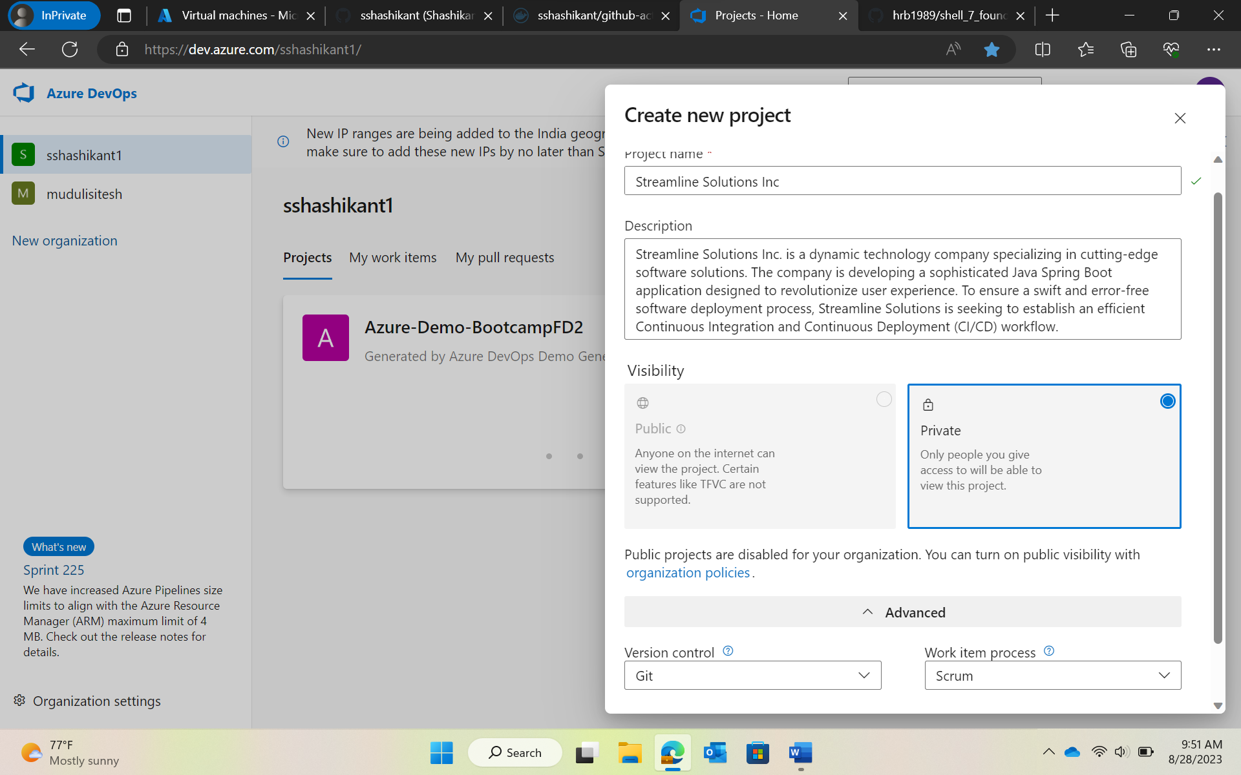

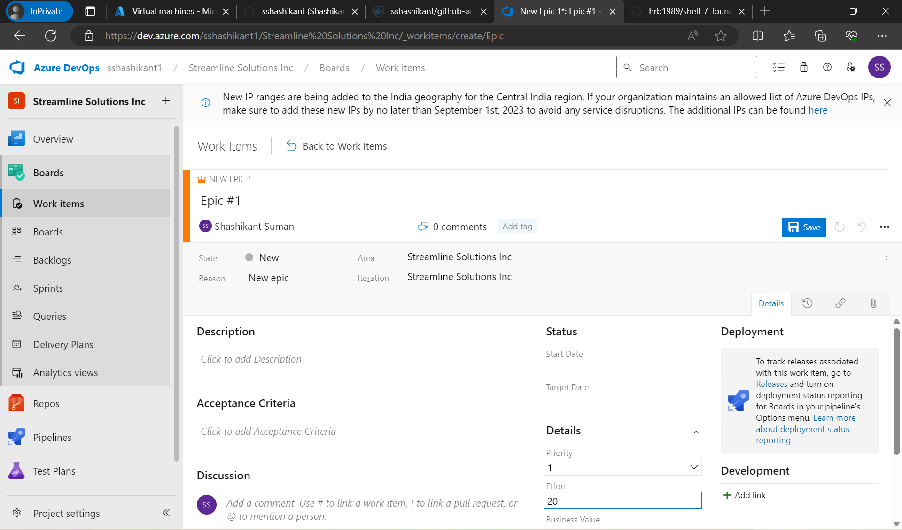

Creating new Epics and Features and connecting them.

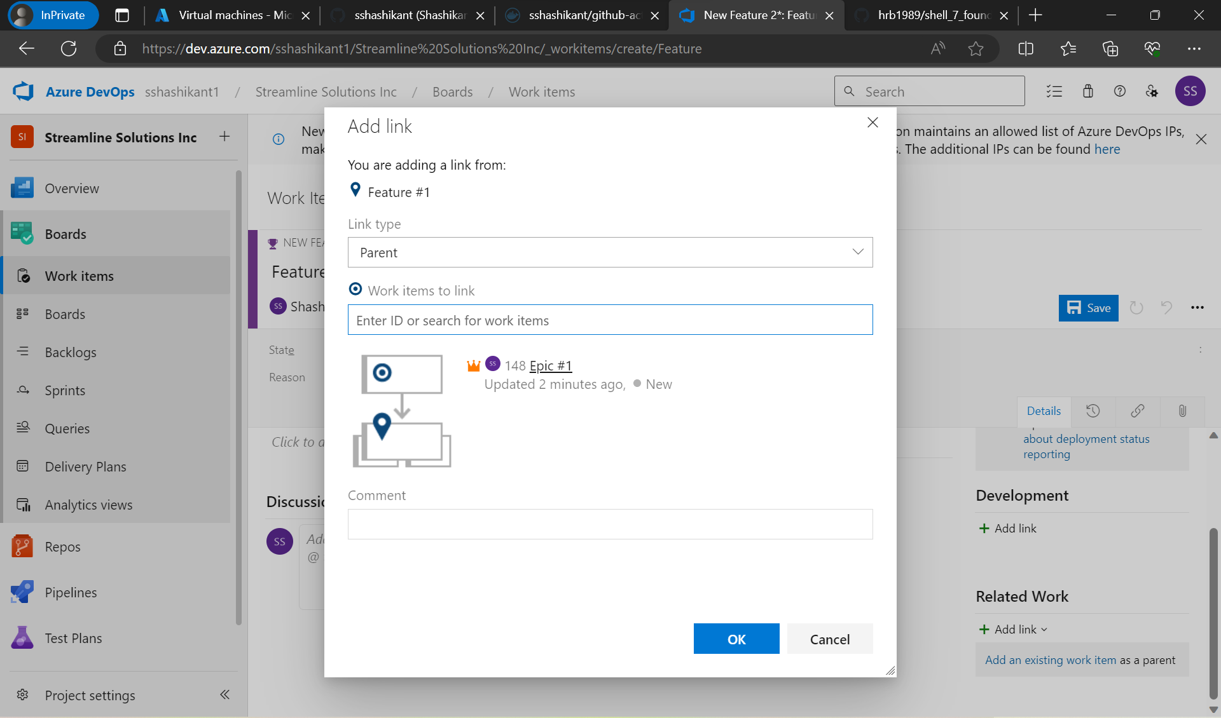

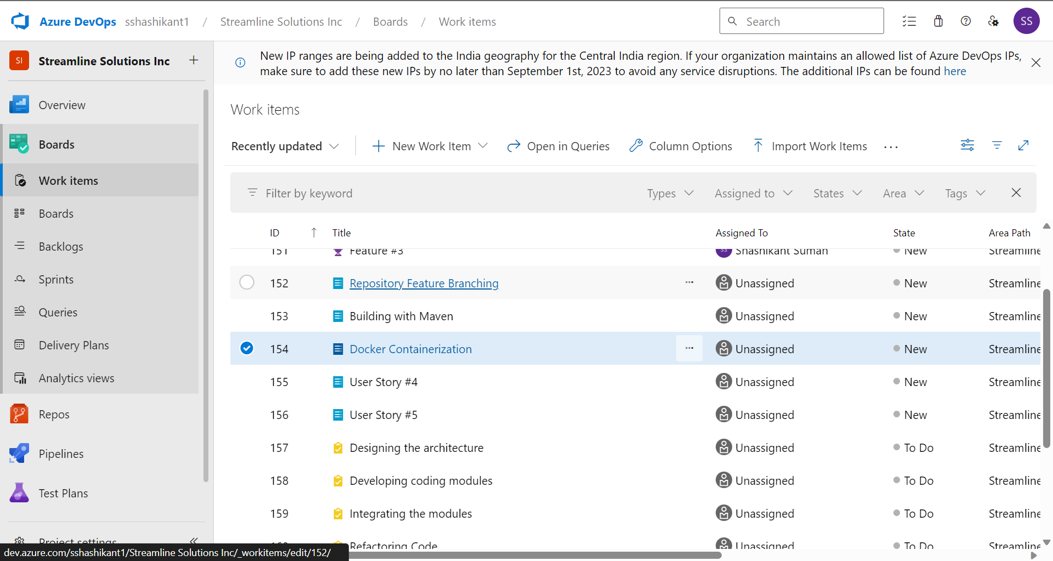

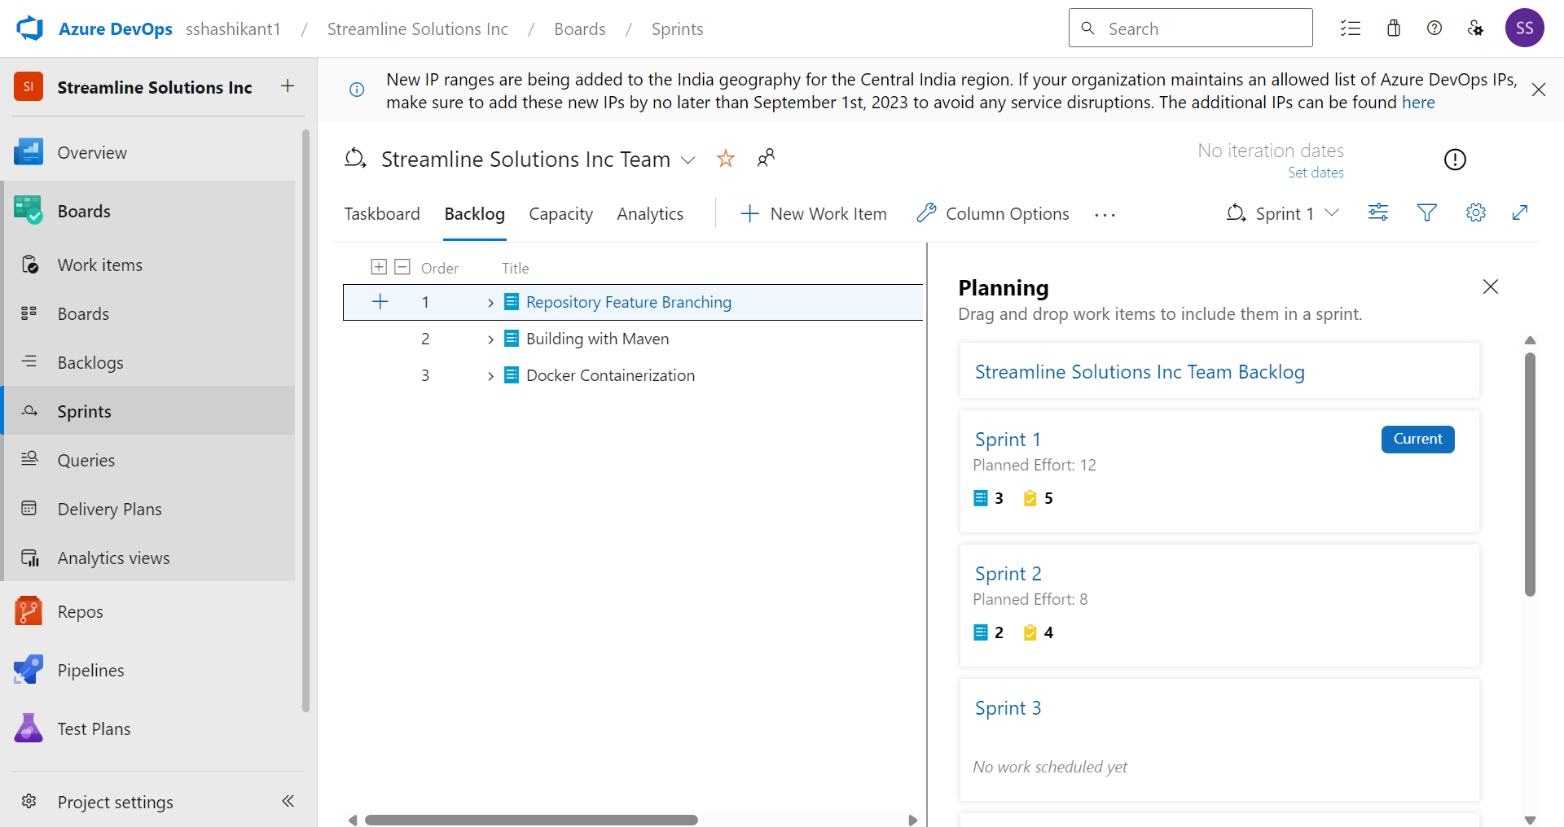

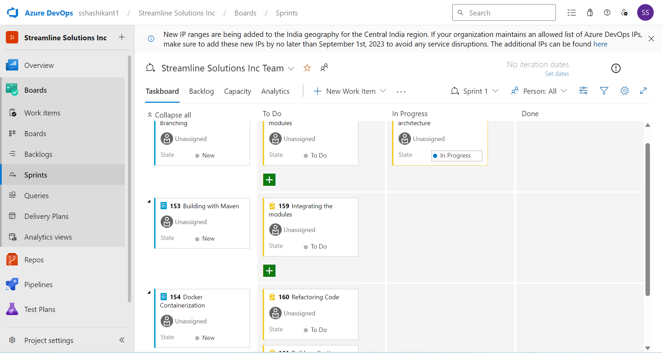

1. GitHub Repository and Feature Branching:

Fork from main branch, add features and then merge it again with the main branch.

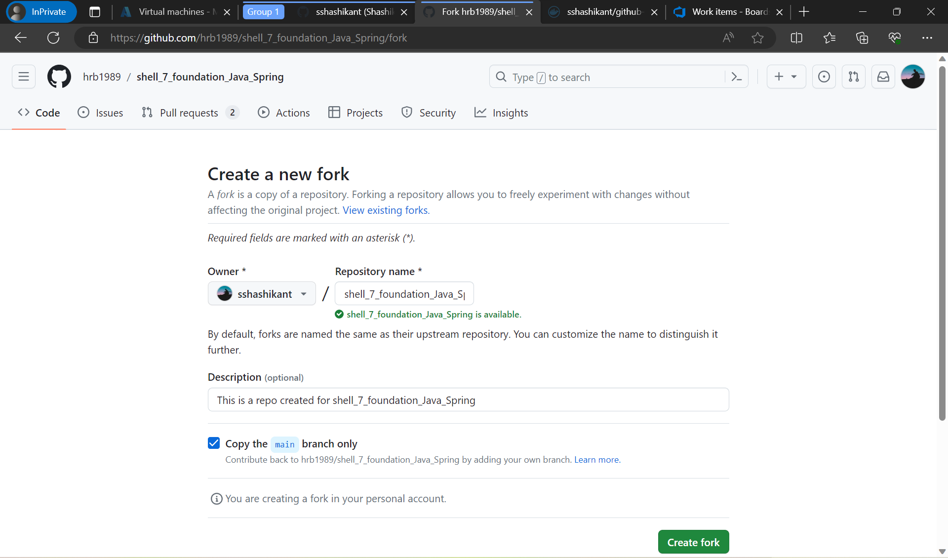

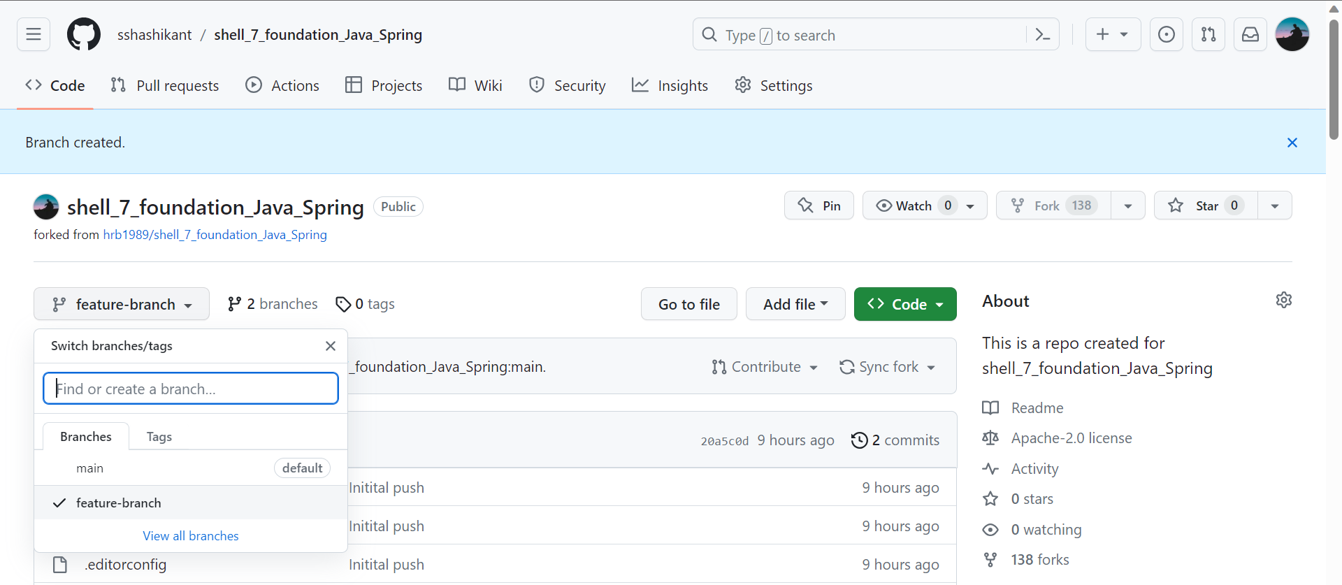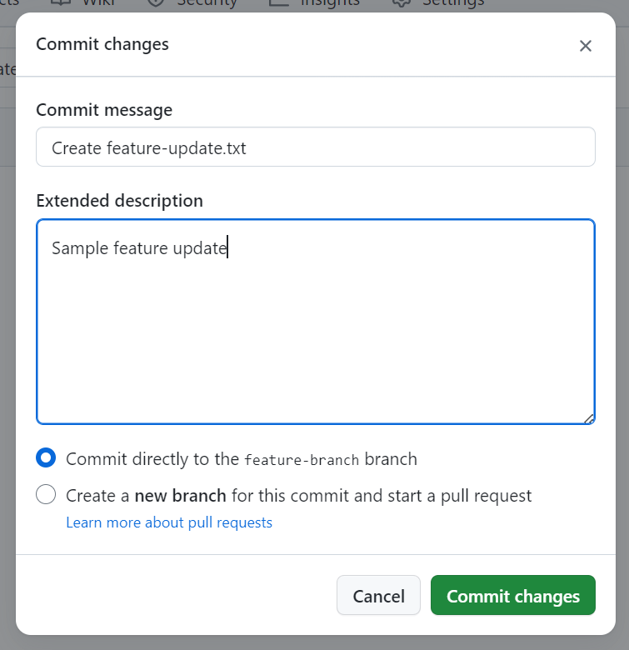

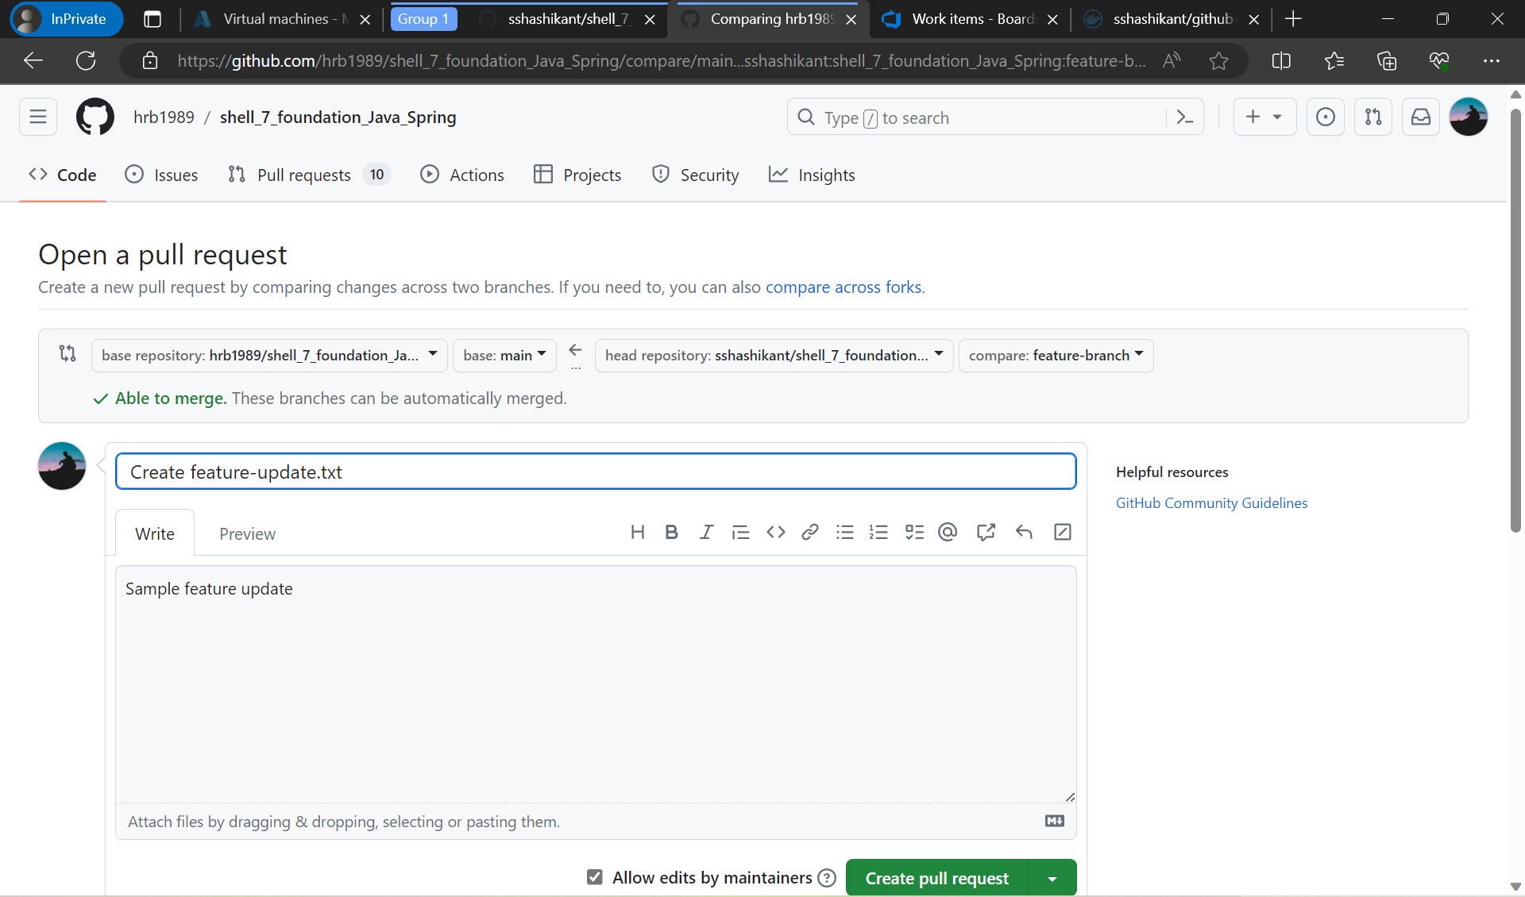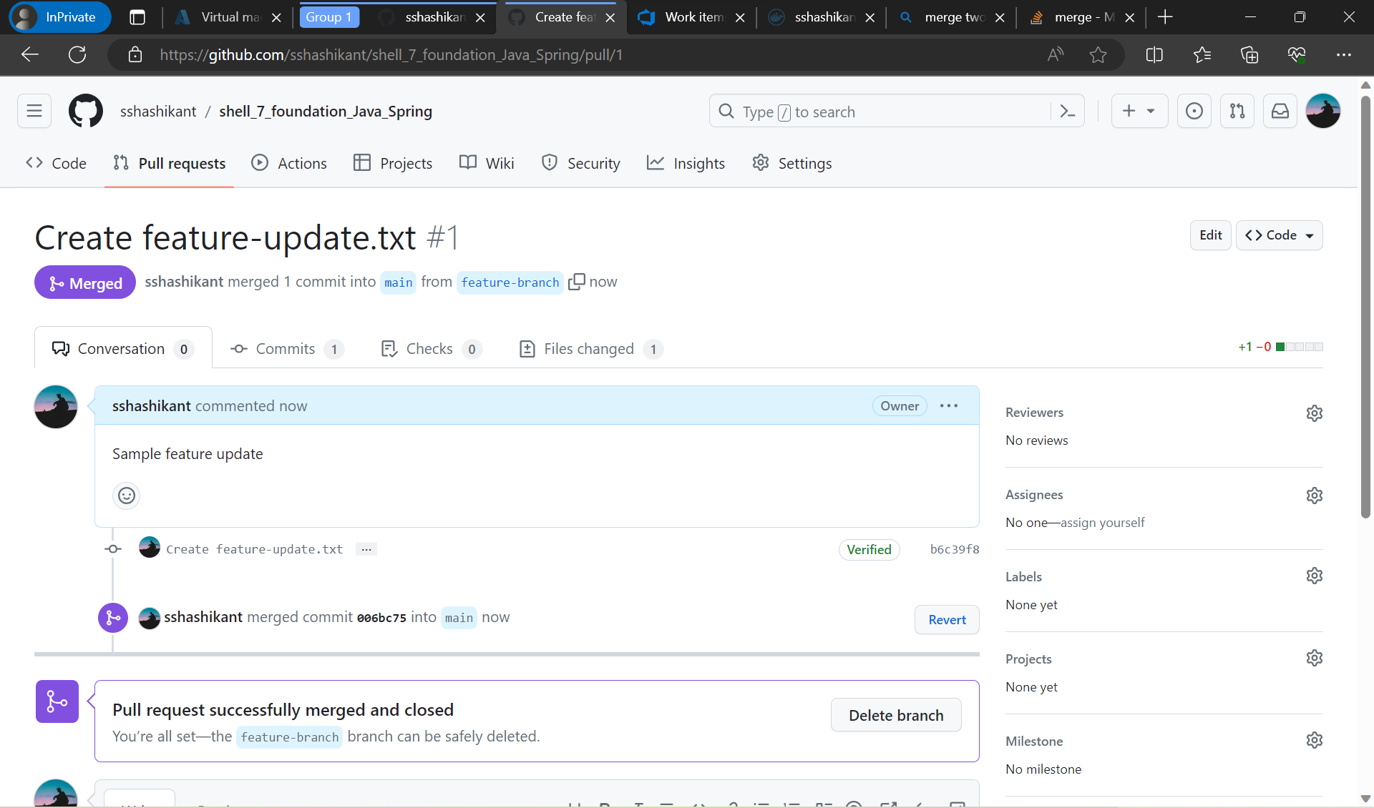

1. Azure VM Configuration: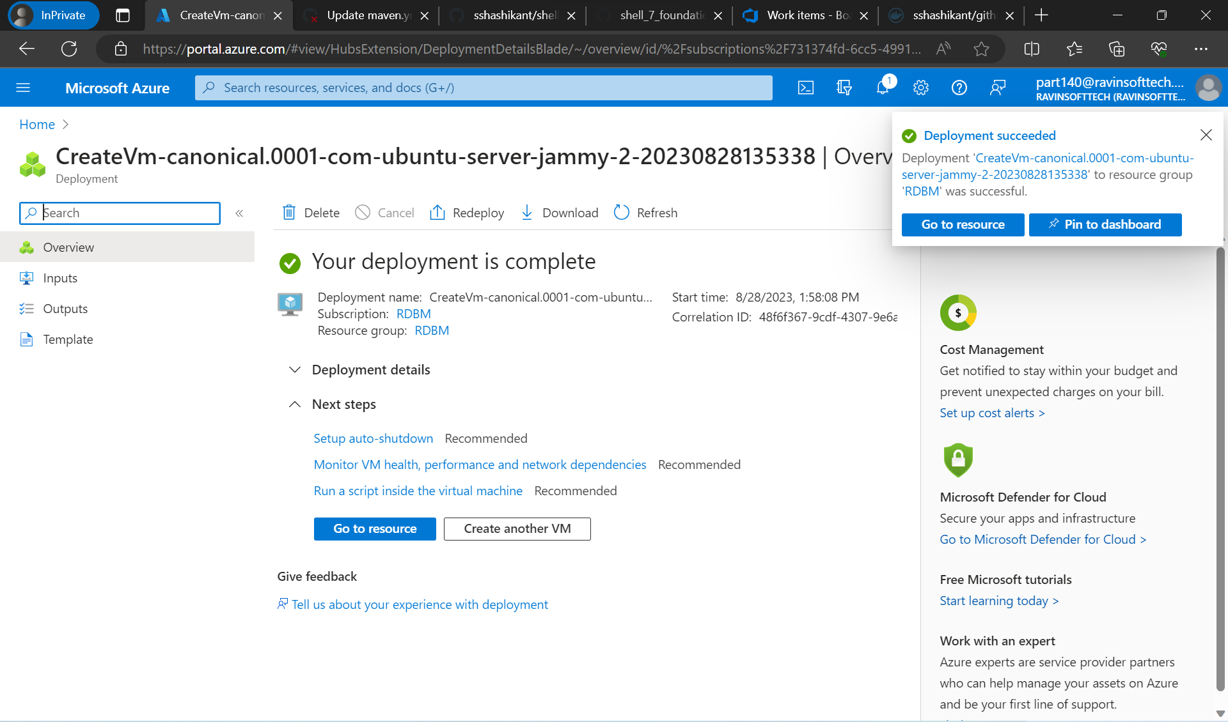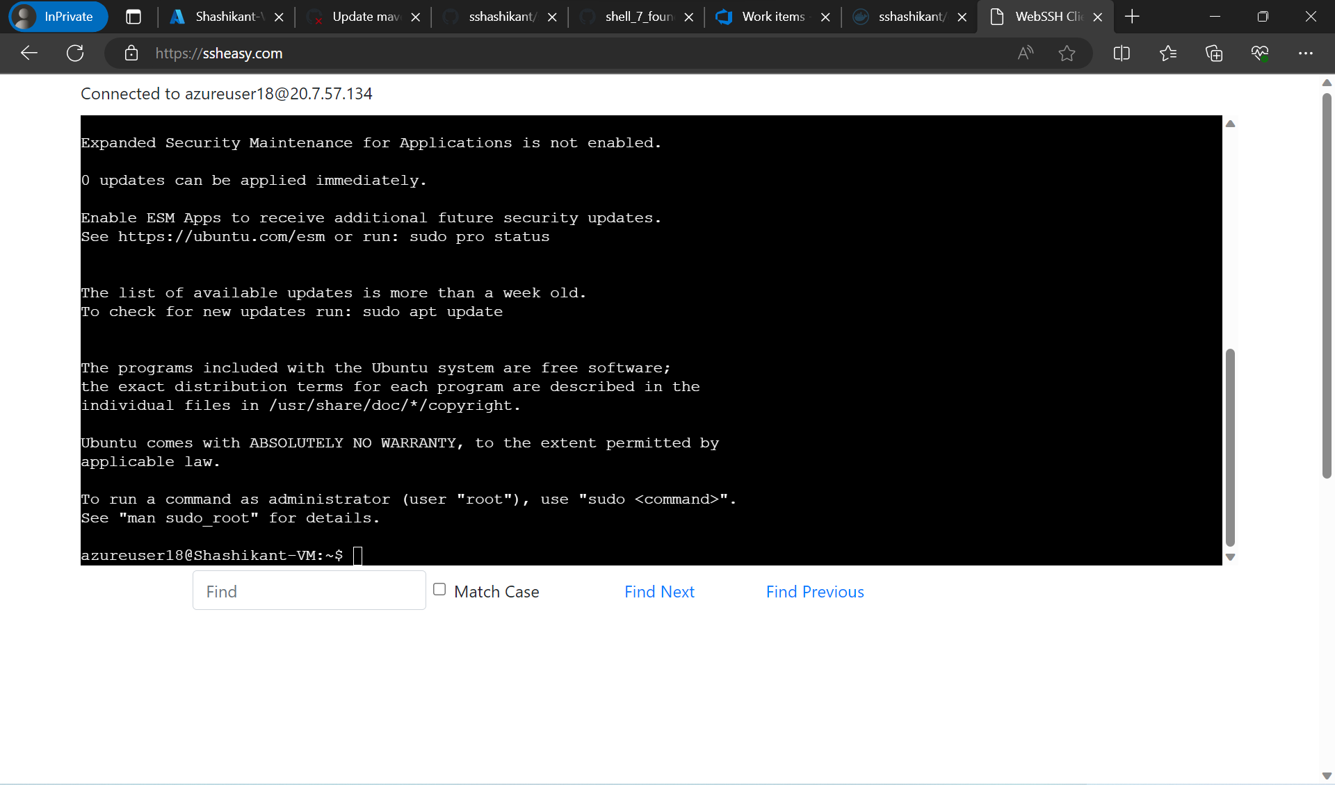
2. Maven-Based Build Process: 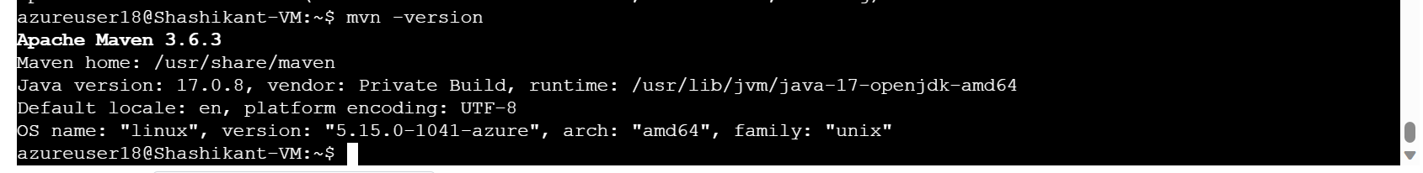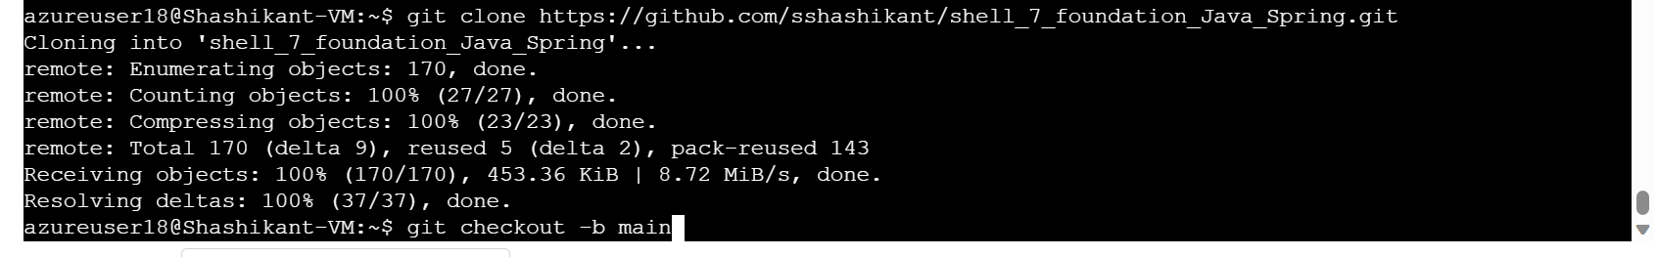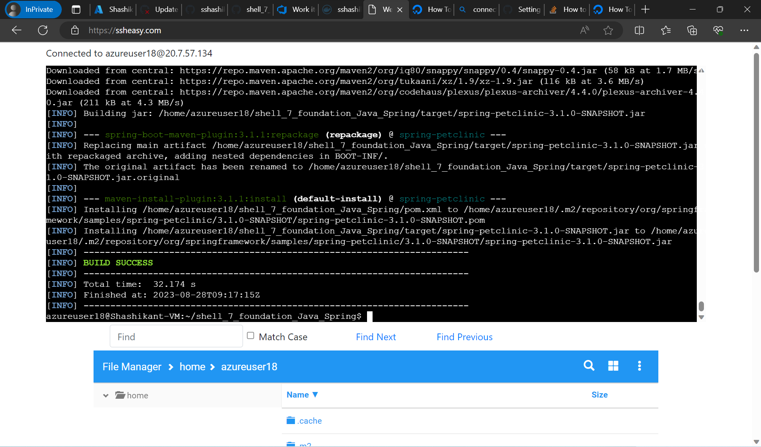
3. Prometheus Monitoring Integration: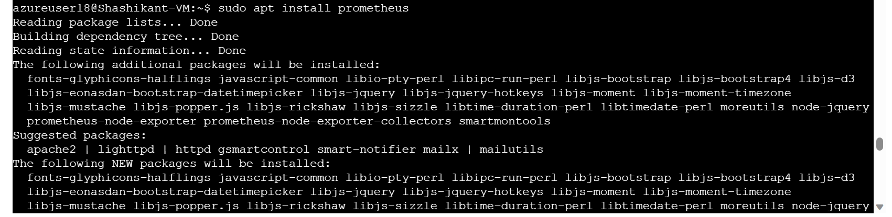
4. Docker Containerization: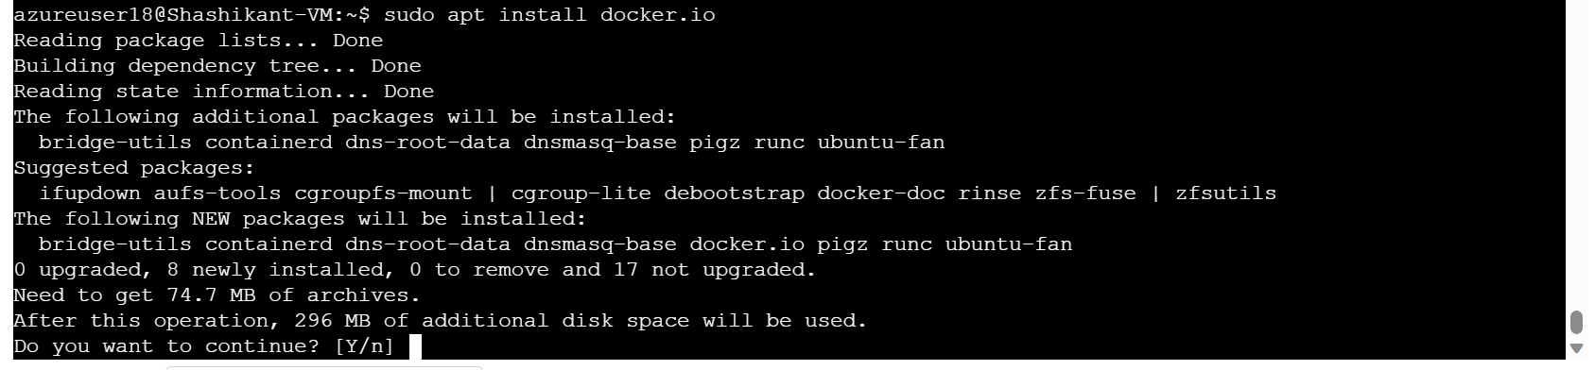

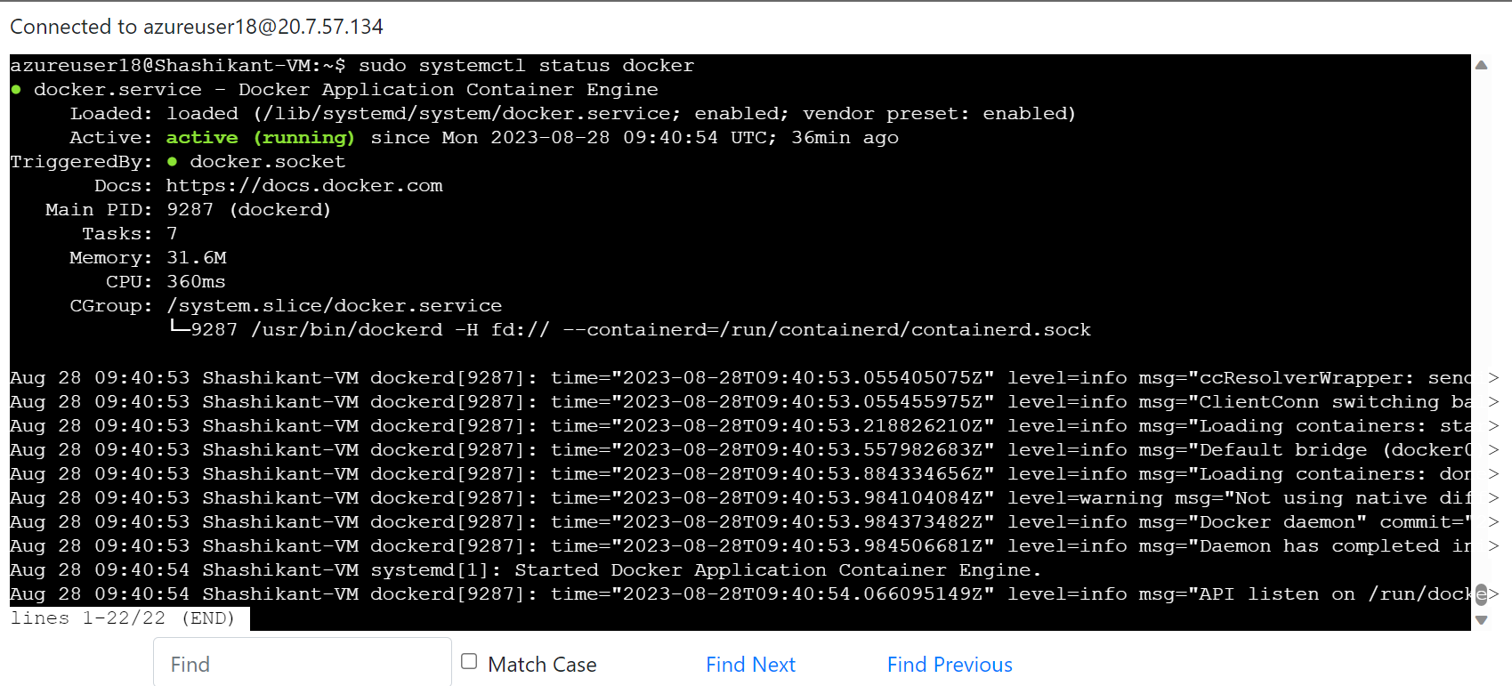

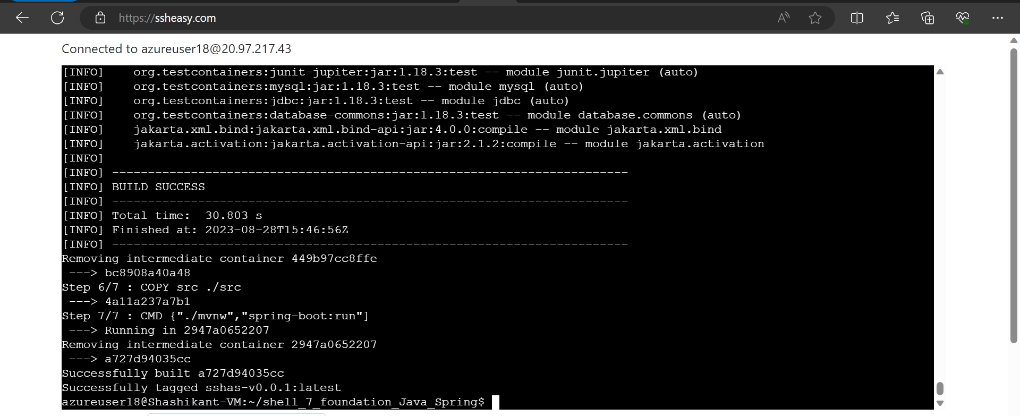

1. Azure Web App Configuration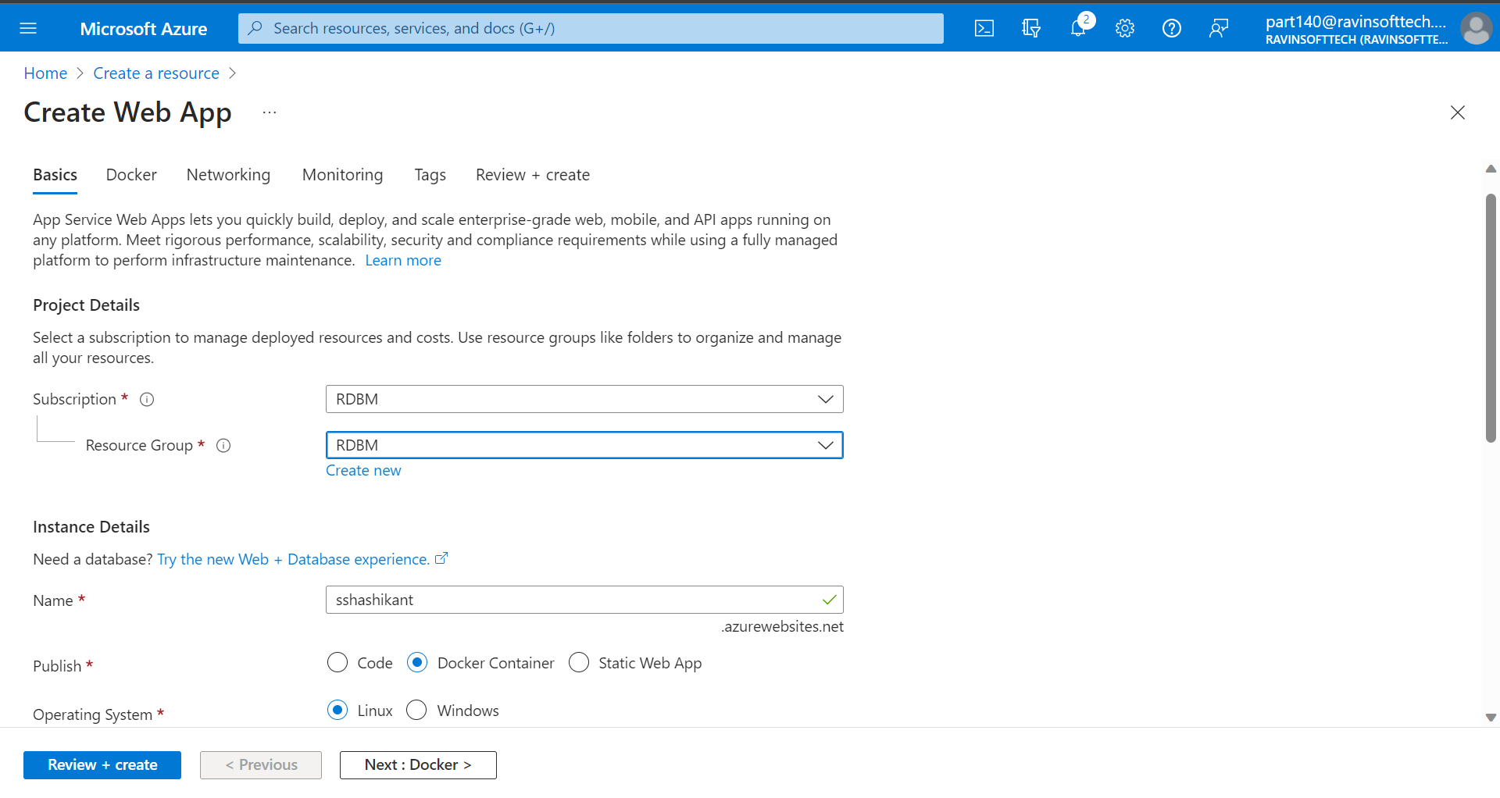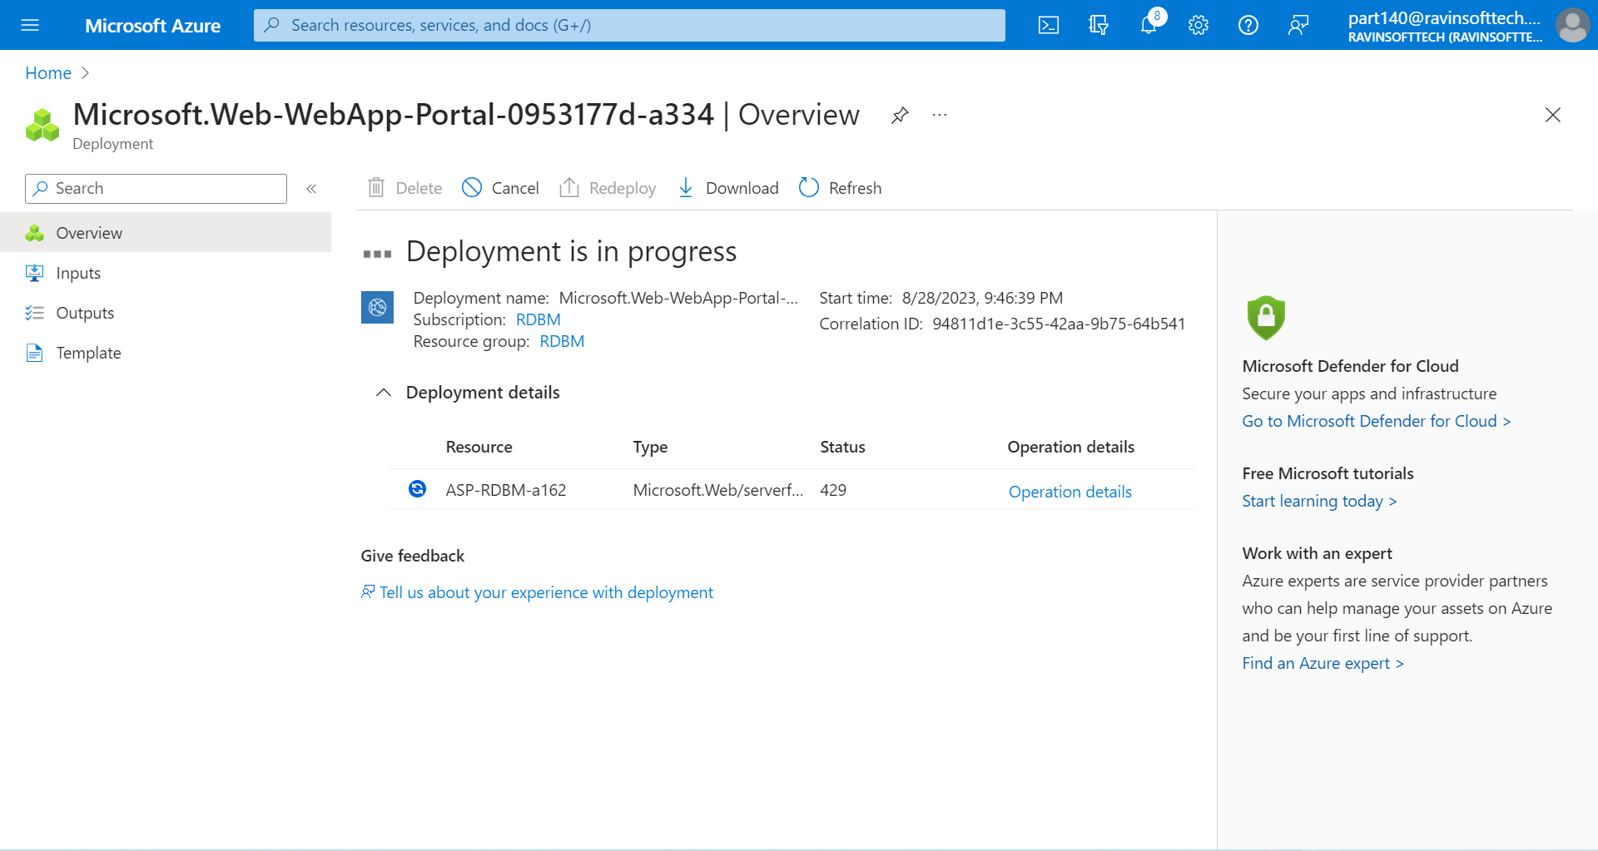
2. GitHub Actions Workflow Implementation:

